Exercise 4:

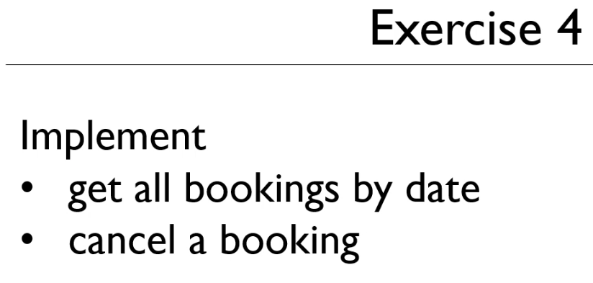

Create the RestBookingsController class in Spring:

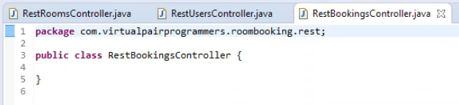

Annotate for a RestController

Create a url mapping

Use autowired to access the repository

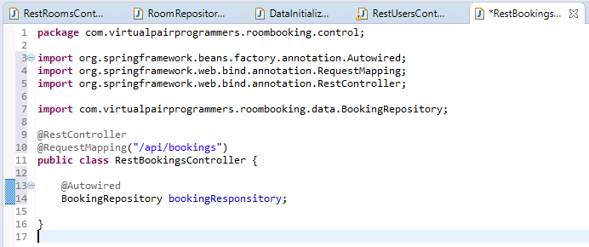

Create method getBookingByDate()

This should have been:  
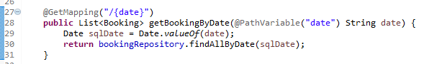

Implement the Delete method:

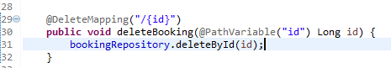

After restarting the app, we can proceed to the data.service.ts

Change the getBookings () method in angular

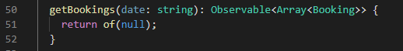

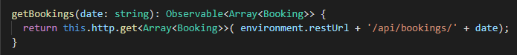

Create a helper method in the Bookings Class with the Models:

Implement the static fromHttp() method

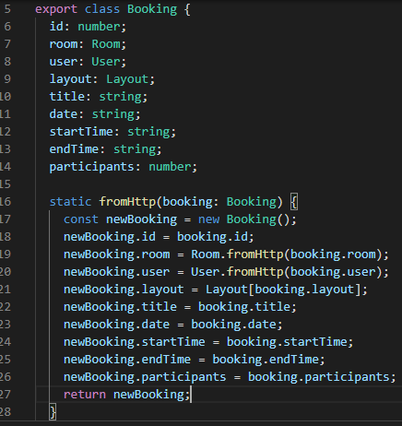

Now we can do preprocessing

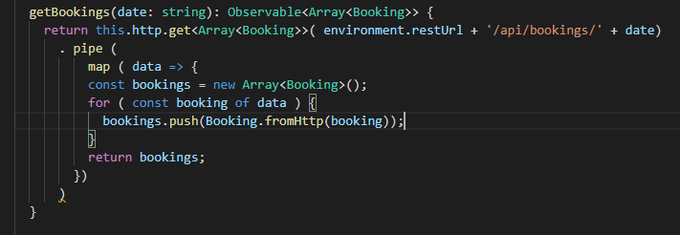

Move to the Calendar component

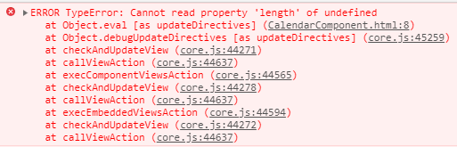

Let us hide the error until the code can be populated: Hide the block within dataLoaded

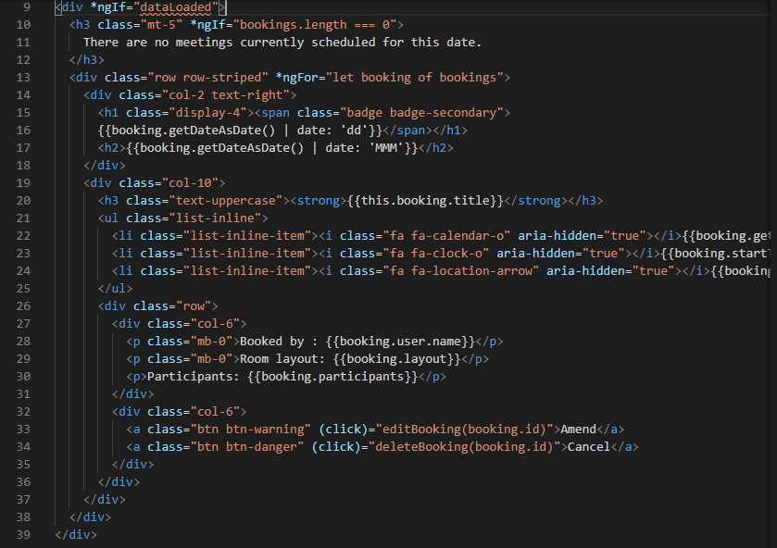

Go back to the Calendar class and implement the dataLoaded Boolean

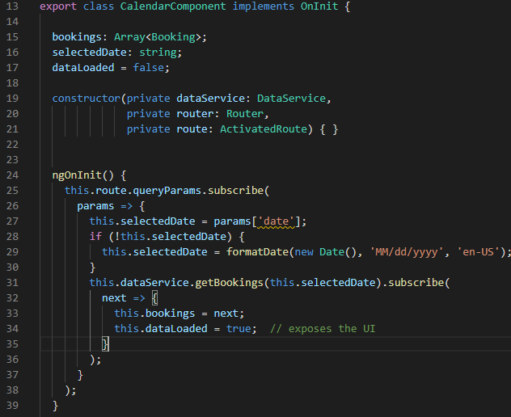

Failing on the Date

{data} changed to {date}



Error handling:

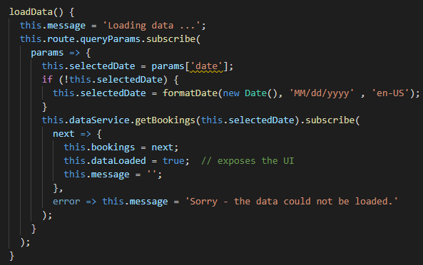

Add message before the hidden div

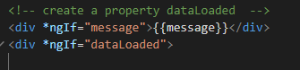

Testing:

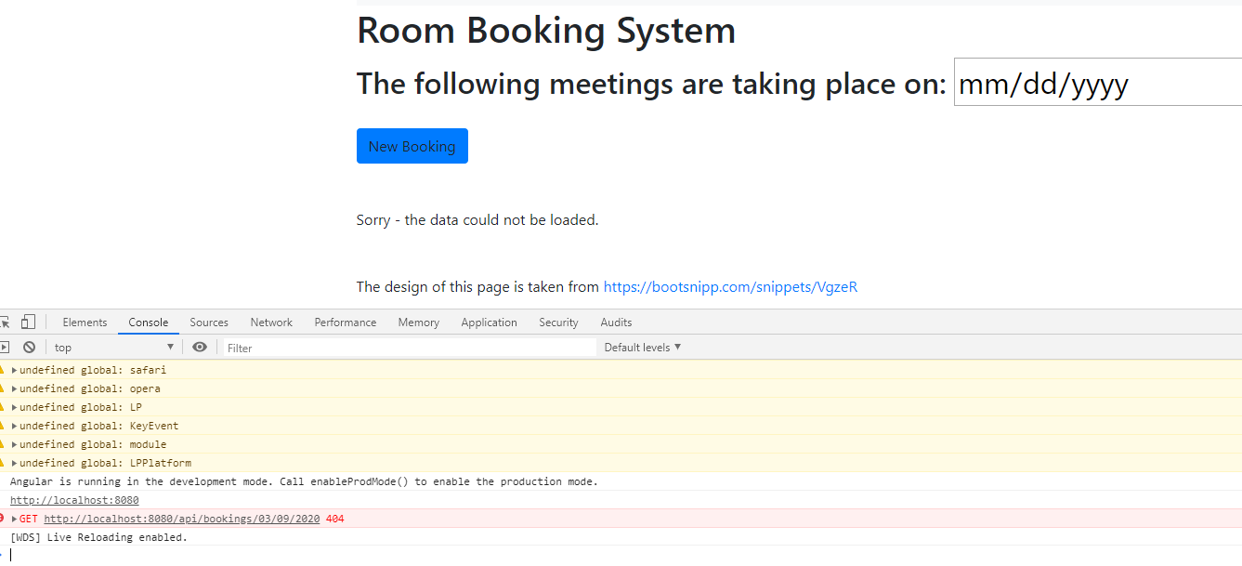

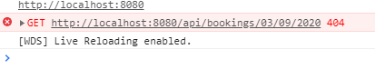

**Using the ‘en-GB’ and ‘yyyy-MM-dd’ overcomes the unknown page 404 error on initial loading:**

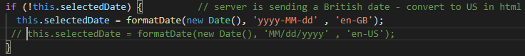

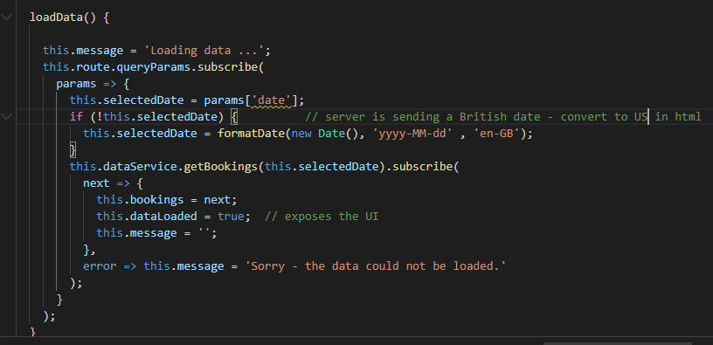

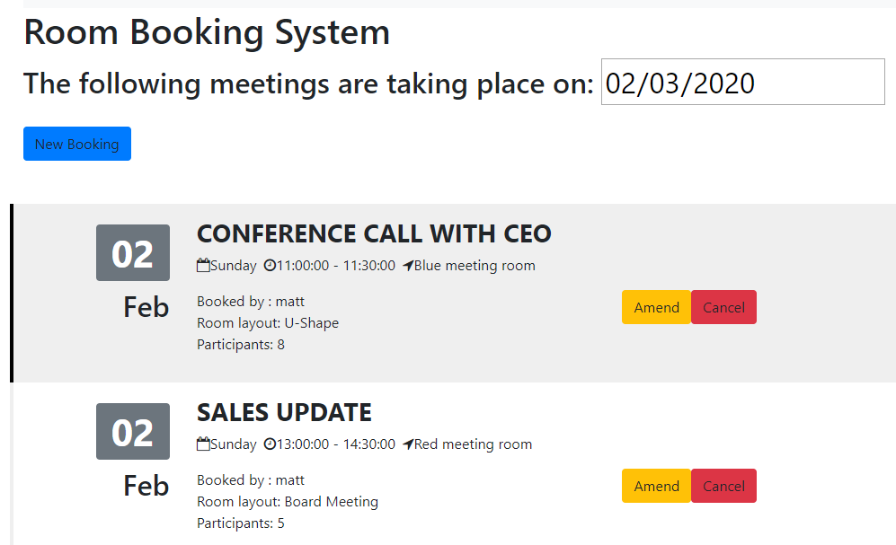

Now, implement Delete booking by clicking on Cancel

In the data.service.ts class

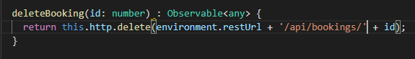

In the calendar.component.ts class

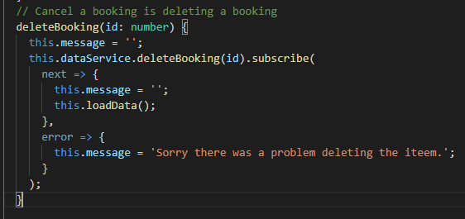

Now, we can test Cancel

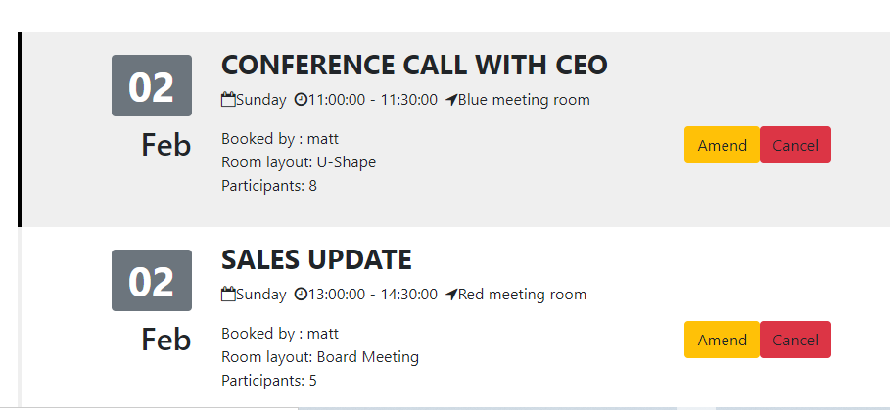

Delete the Conference Call with CEO

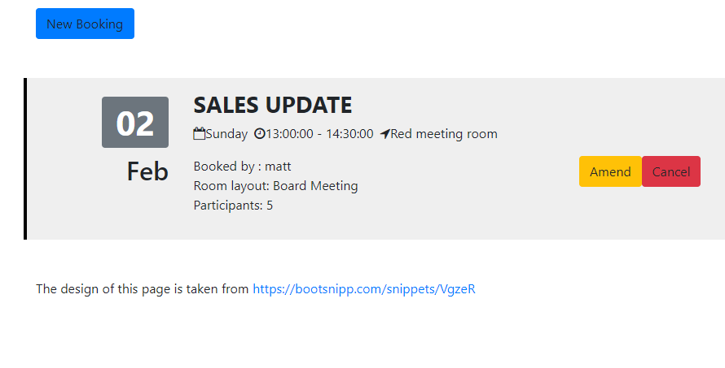

It works!!

Put in a Warning on Delete:

Go to the room-detail-component.ts and put in the Warning Code – use the confirm() method which returns a boolean

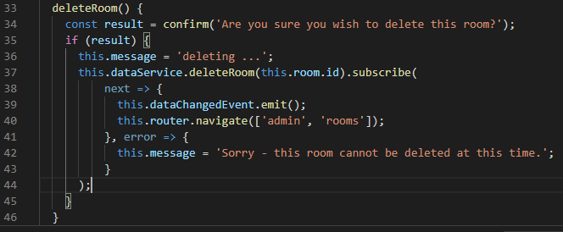

Let us test this:

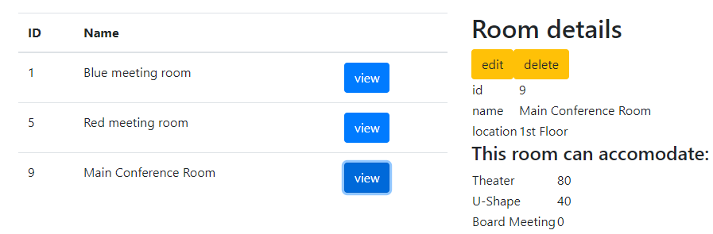

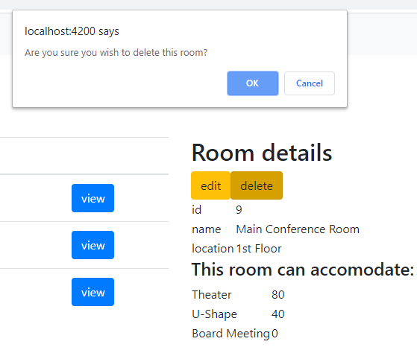

Click Ok to follow through:

